
NISHULK PRABHAT HIGH SCHOOL
NISH-SHULK HINDI TELUGU MADHYMIC PATHSHALA
#6-1-621Vegetable Market Road, Khairatabad -500004
 : nishulkprabhath@gmail.com 8500601941 www.nishulkprabhat.com
OUR MOTTO :
Empowering Dreams, Igniting Futures
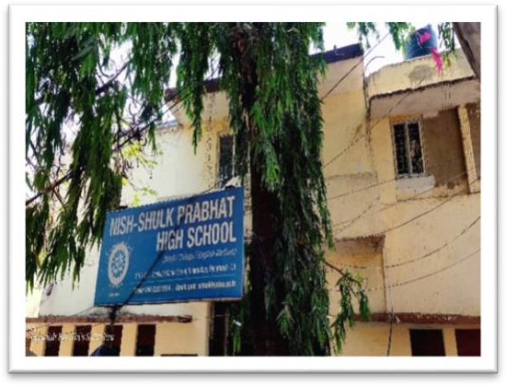
Our motto reflects the aim of our school to empower students to pursue their dreams through education and support, while also igniting their potential for a brighter future filled with opportunities despite financial limitations.
HISTORY:
Established in 1941 by visionary educator Shri Bhaktawar Singh, the school was founded to provide education to underprivileged children. At a time when such initiatives faced many challenges, the institution began as a Hindi-Telugu medium school. Over the years, it evolved into an English medium institution, adapting to changing educational needs while remaining true to its founding mission.
ABOUT SCHOOL:
True to its name, "Nishulk", meaning free of cost, the school stands as a beacon of accessible education where no child is burdened with fees. Despite government teacher vacancies remaining unfilled for more than 25 years, the school continues to function successfully under the guidance of dedicated management. The progress of the school has been possible due to the generosity of well-wishers and donors who have supported our mission.
IMPACT ON STUDENTS' LIVES:
All our students hail from underprivileged backgrounds, many being the first in their families to receive education. Our school serves as their entire world, providing them with not just education, but also nourishment, recreation, and a sense of belonging. Our mission is to equip them with quality education to foster strength, confidence, and promising career prospects. Additionally, we offer vocational training to pave the way for future earning opportunities and impart basic computer skills to keep them abreast of technological advancements beyond the classroom.
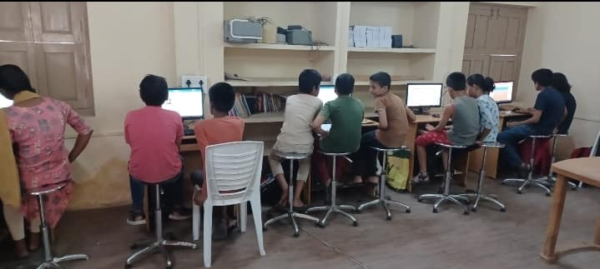
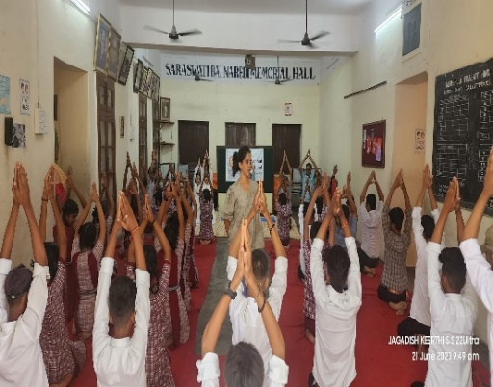
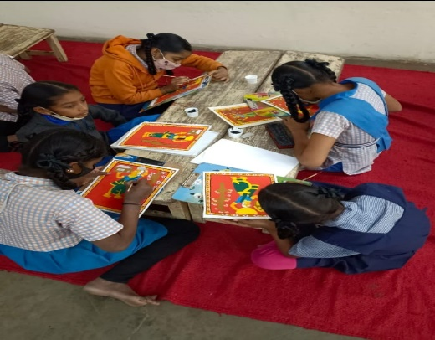

INFRASTRUCTURE:
Our school offers spacious, well-ventilated classrooms from grades 1 to 10, equipped with modern amenities like projectors and laptops. With a fully-equipped computer lab, library, science lab, and sports room, we ensure a holistic learning experience through interactive education, hands-on experimentation, and physical activities. All classrooms are digital classrooms equipped with projectors and laptops.
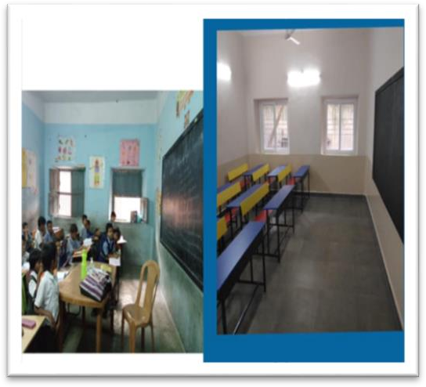
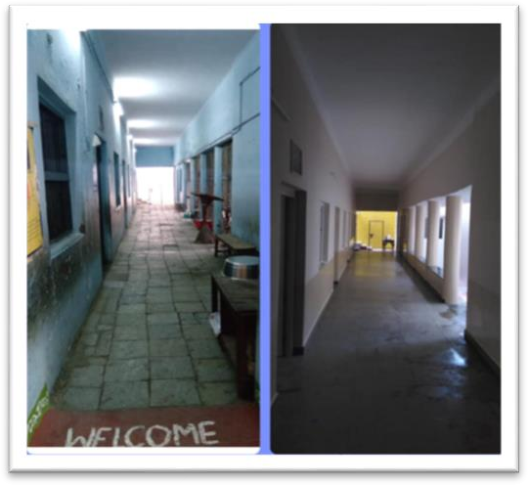

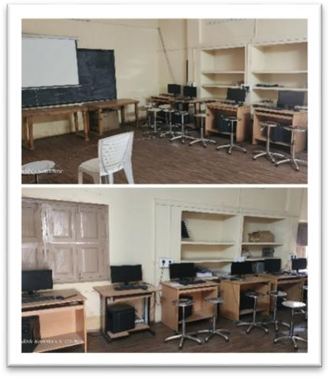
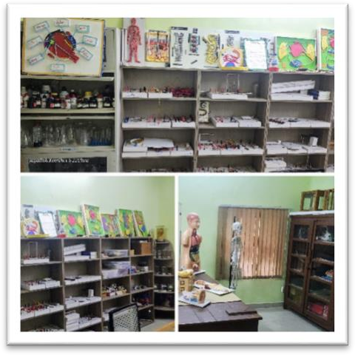
BEFORE AND AFTER RENOVATION
SCIENCE LAB COMPUTER LAB
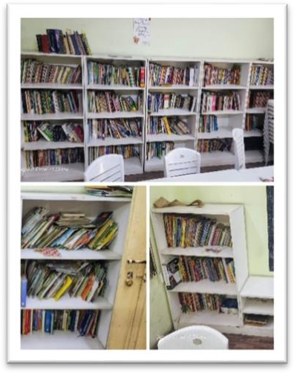
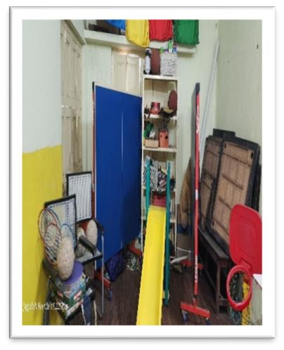
COMPUTER LAB SPORTS ROOM

TEACHING METHODOLOGY:
With a 25:1 student-teacher ratio, digital classrooms, weekly computer sessions, library and sports periods, we ensure holistic learning. Senior students participate in hands-on science experiments, encouraging critical thinking and practical understanding.

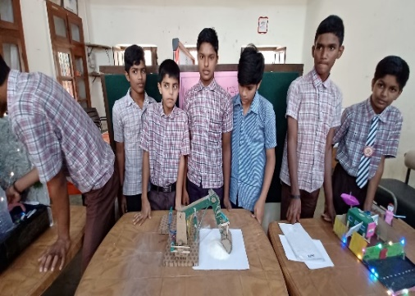
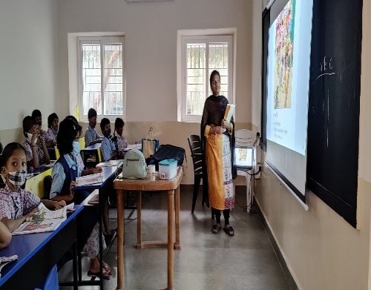
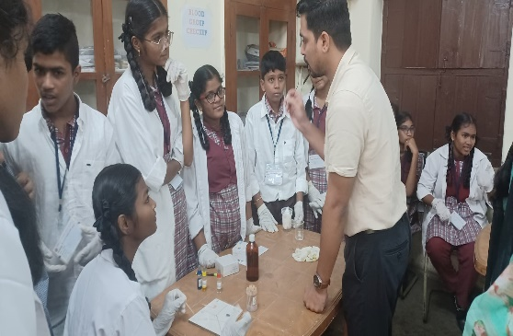

STUDENT DEVELOPMENT PROGRAMMES:
- Mentorship Programs: We connect students with mentors who can provide guidance and support, whether it's academic, career-oriented, or personal development.
- Career Counselling: We offer career counselling sessions to help students to make informed decisions about their education and career choices.
- Life Skills Education: We incorporate life skills education into the curriculum to equip students with essential skills such as communication, problem-solving and time management.
- Scholarship Opportunities: We provide scholarship opportunities for students who show exceptional academic performance.
- Technology Integration: We continuously integrate technology into the curriculum to ensure that students are familiar with digital tools and platforms.
- Support for Further Education: Provide support, scholarship and resources for students who wish to pursue higher education after completing their schooling.

- Health and Nutrition Programs: Regular health check-ups are conducted, and students receive fruits to promote healthy eating habits..
- Monitoring and Evaluation: We regularly monitor the progress of students and evaluate the effectiveness of programs and interventions.
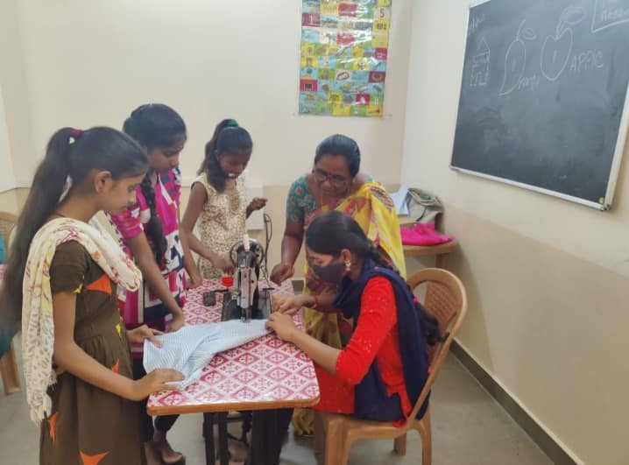
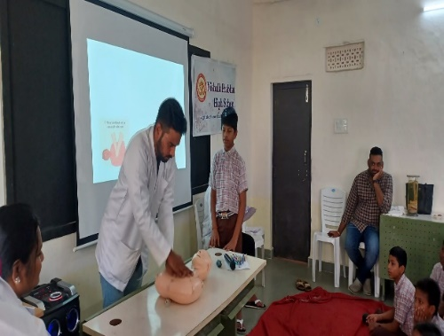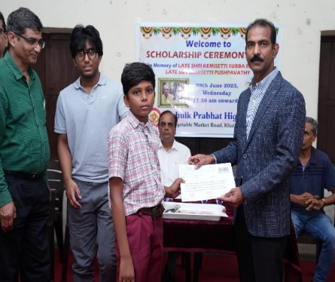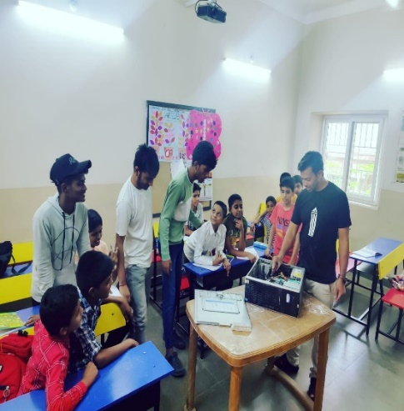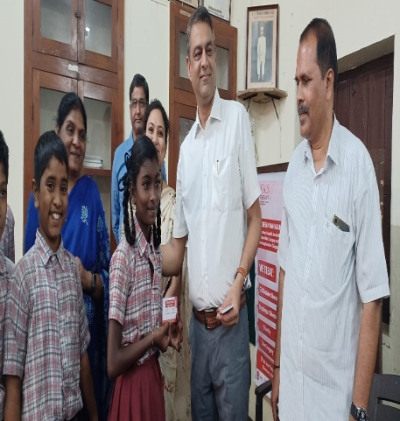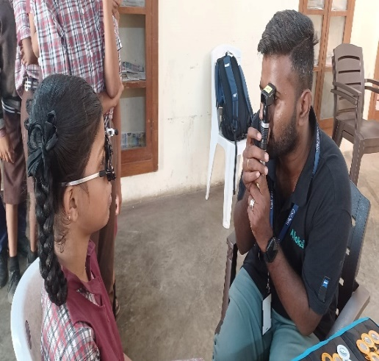

CO-CURICULAR ACTIVITIES
Students participate in cultural programmes, sports competitions, art activities, and value-based education sessions throughout the year.
. 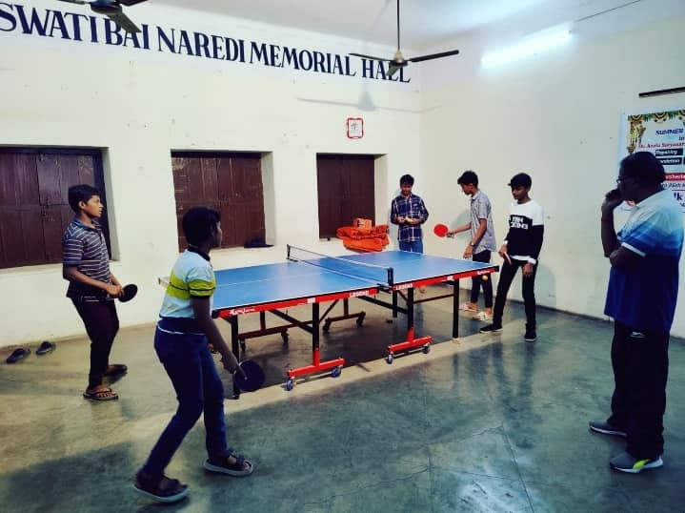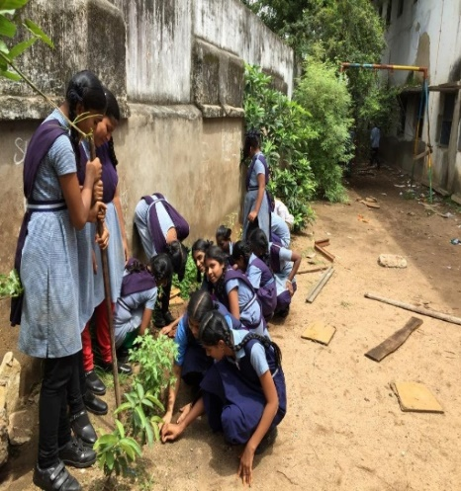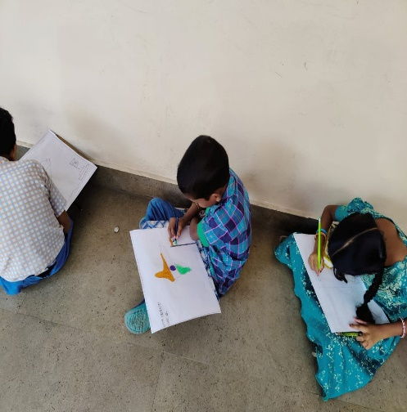

SYLLABUS:
By following the Telangana State Board syllabus with the CCE pattern, our school aims to provide a well-rounded education that not only focuses on academic excellence but also nurtures students' overall growth, preparing them for success in both their academic pursuits and life beyond the classroom.
RESULTS:
Our Class 10 pass percentage consistently exceeds 95%, reflecting the dedication of students and teachers. Special after-school support classes ensure personalized attention for every learner.

HOW ARE THE DONATIONS USED?
- Teacher Salary
- Student Sponsorship
- Stationery
- Remedial Classes
- Worksheets
- Prizes
- Student Nutrition
- Events
SUPPORT FROM WELL WISHERS:
We sincerely thank all our supporters and donors for helping us empower dreams and ignite futures.
MANAGEMENT MEMBERS:

PRESIDENT - Shri Shravan Kumar Naredi
VICE- PRESIDENT – Maj G. Shiv Kiran
SECRETARY – Shri Rakesh Bhatnagar
TREASURER & CORRESPONDENT
Shri Govind Prasad Chandak
JOINT SECRETARY
Shri Prakash H Bhandari
Smt Praneetha Agarwal
MEMBERS – Shri Ashok Naredi
Smt Lalitha Tibrewal
Smt K. Gouri Mohini
HEADMASTER – Shri Y.Karunakar Reddy

 Kindly support our school’s noble cause of providing quality and free education to the underprivileged.
Contributions can be made to:

Bank Name: UNION BANK OF INDIA.
Ifsc Code : UBIN0803103.
Account No: 031010011001402.
Cheques for the sponsorship can be issued in favour of
NISH-SHULK PRABHAT HINDI-TELUGU MADHYMIC PATHSHALA

Donations to the school are eligible for tax exemption under Section 80G, and we also welcome CSR partnerships. We invite organizations and individuals to support our mission of providing quality education to underprivileged students.

For Updates:

- Nishulk Prabhath
 nishulkprabhath

